INSTALL & SETUP GIMP 2.8 in “Single Window Mode”
INSTALLATION:
Download GIMP 2.8 from: http://www.filehippo.com/download_the_gimp/ this is a 72.8MB file and may take five minutes on a slow internet connection.
When download is complete, follow the prompts to install it. The default location is in C://Program Files/ but you can change this if you prefer. The installation will take a few more minutes – allow the GIMP shortcut to go on your desktop.
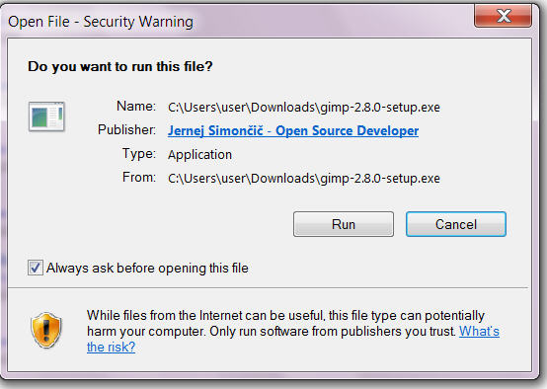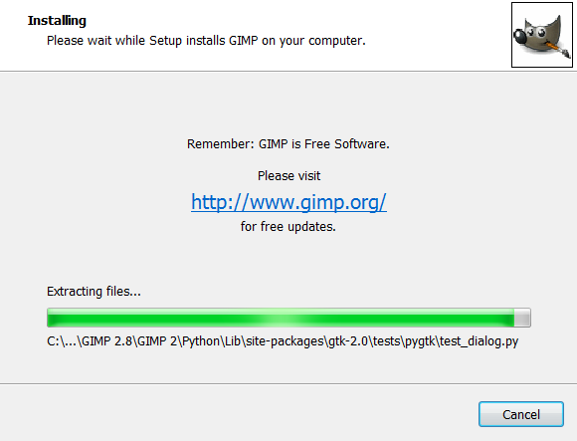
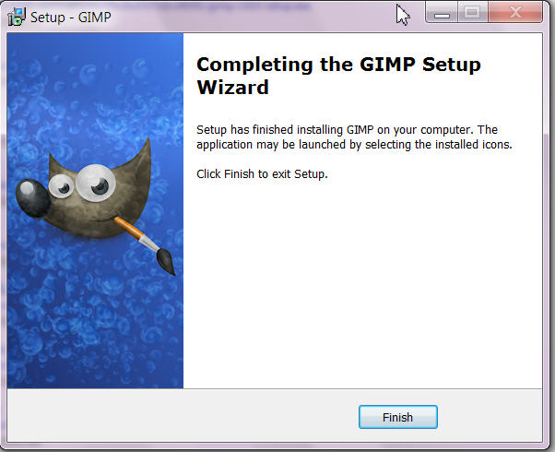 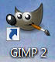 Desktop shortcut

SETUP (Single Window Mode):
- Start GIMP from desktop shortcut
- On menu bar, click Windows > Single-Window Mode
- At top right, click to make full screen
- Adjust Toolbox width using <||> just to the right (I like 6 icons wide)
- IMPORTANT to maintain single window:
- Click Edit > Preferences > Window Management
- Tick “Save window positions on exit” > Save Window Positions Now > OK
- Enjoy the power of GIMP

